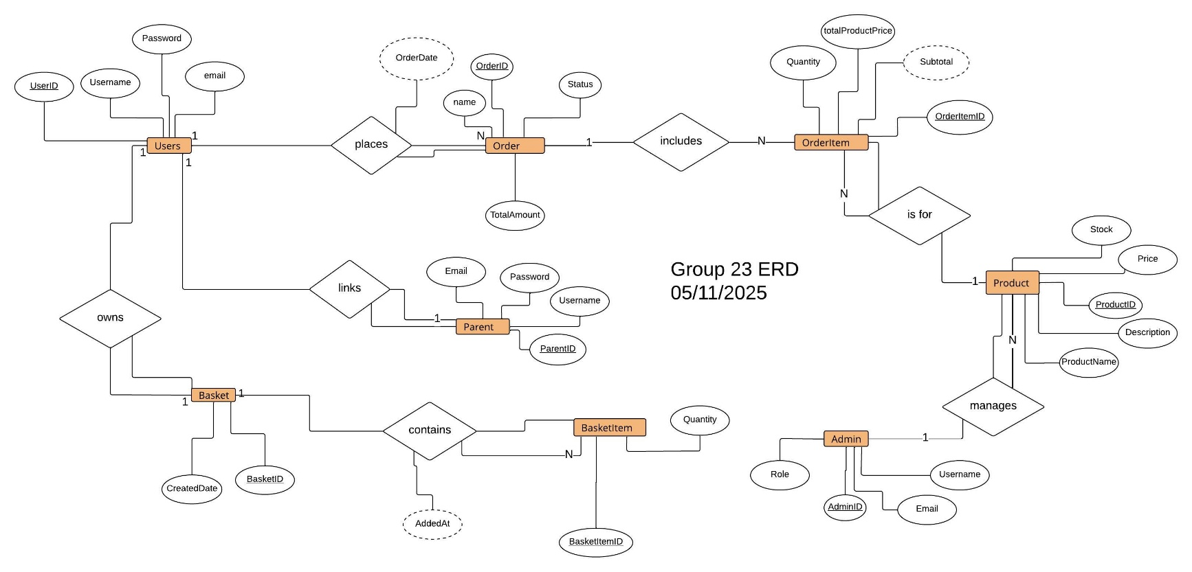
This Entity-Relationship Diagram (ERD) illustrates how users, orders, products, and related entities interact within the system. Each rectangle represents an entity, such as Users, Orders, or Products, while diamonds show the relationships between them. Attributes are displayed as ovals, with underlined names marking primary keys and dashed ovals indicating derived or relationship-based attributes.
A user can place multiple orders, each containing one or more order items linked to specific products. Every product is managed by an admin, ensuring data and inventory are properly maintained. Users also own baskets, which can contain several basket items that track quantities and added dates. Parents are linked to users for account association and management purposes.
This ERD provides a clear view of how data flows and connects across the database, helping maintain structure, consistency, and efficiency in managing users, orders, and products.

